MACH4METAL

metalworking machinery
Transito 21
6909 DA BABBERICH Netherlands
Tel. +31 (0)316-247123
Fax: +31 (0)316-247956
info@mach4metal.com
www.mach4metal.com

Bank No : 66.52.13.883
IBAN : NL33 INGB 0665 2138 83
BIC : INGBNL2A

DURMA Press brake 4000 x 200 Ton
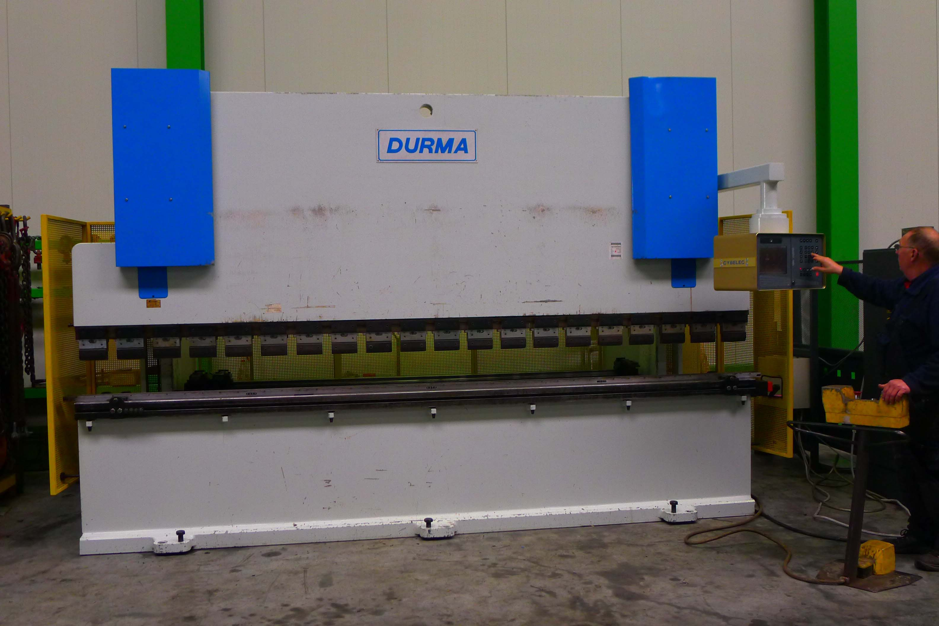

- Make : DURMA
- Typ : HAP 40 200
- No : 754 3011 38
- Age : 2000 in work 2001

- Max. bending length: 4.050
- Between column : 3.100
- Max. force : 200
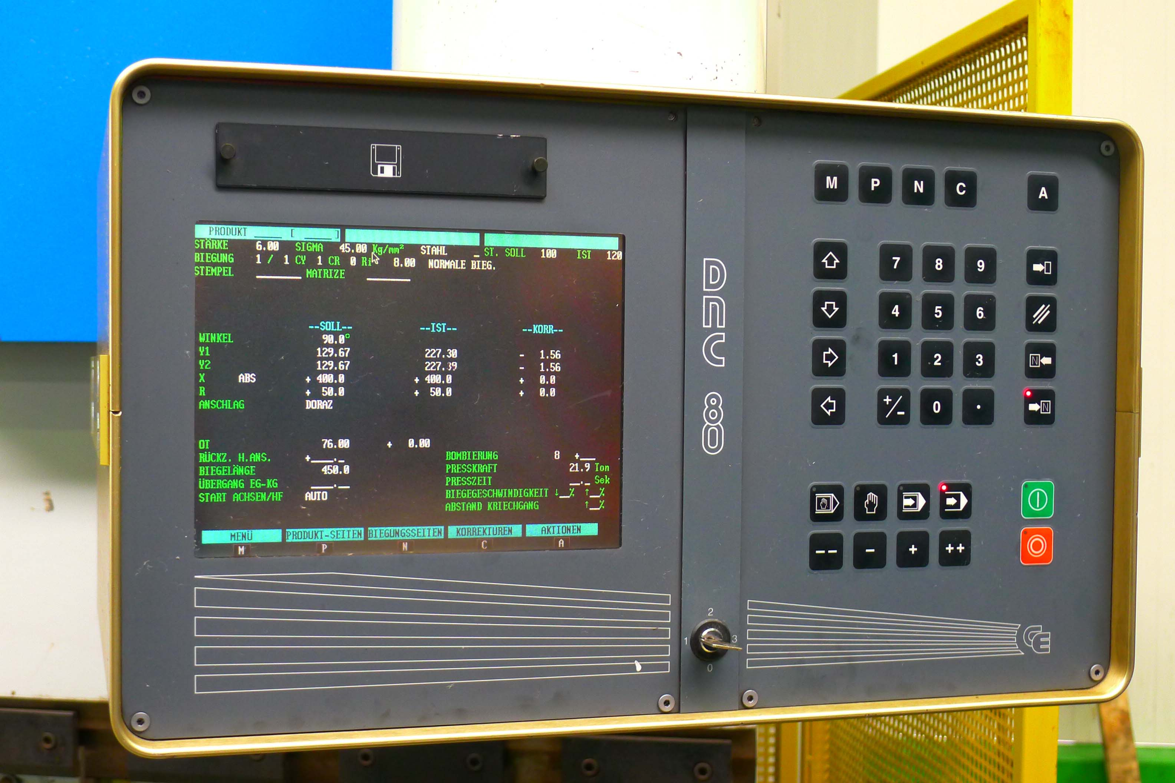

- Beam stroke : 210 mm
- Depth of throat : 350 mm
- Table width : 140 mm

- Approach speed : 100 mm/min
- Bending speed : 7 mm/min
- Return speed : 73 mm/min
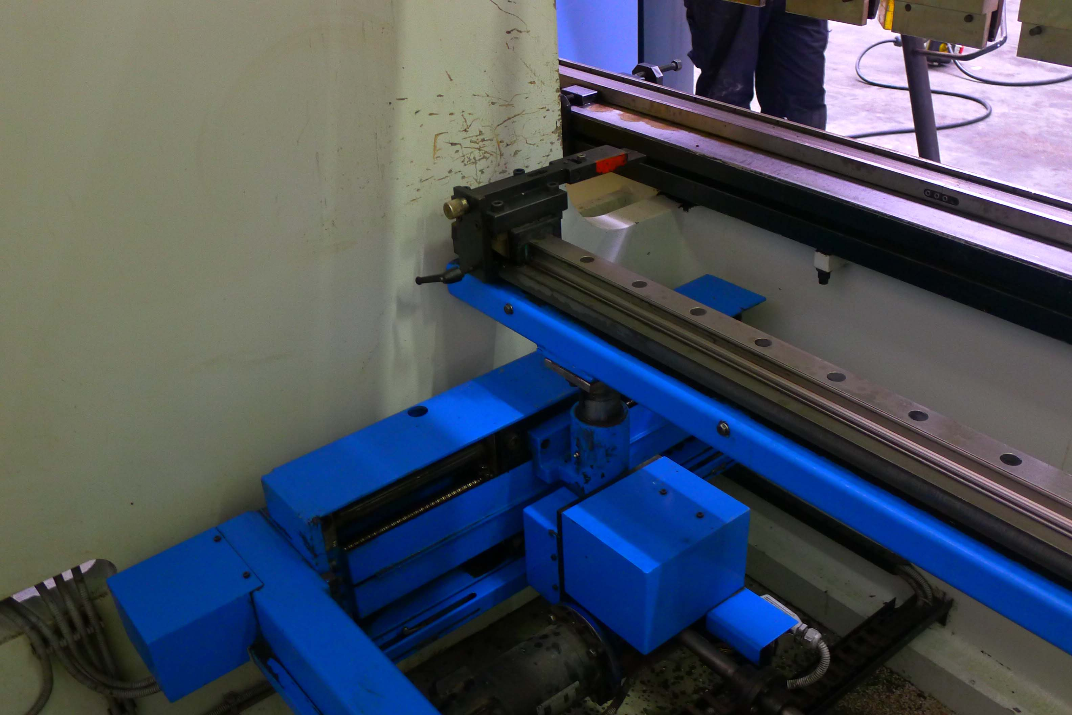

- Cybelec DNC 80
- Axis Y1 / Y2 / X / R & 4 x Z with hand.

- Power 400 V / 15 kW
- Oil capacity 150 L

- Dimensions
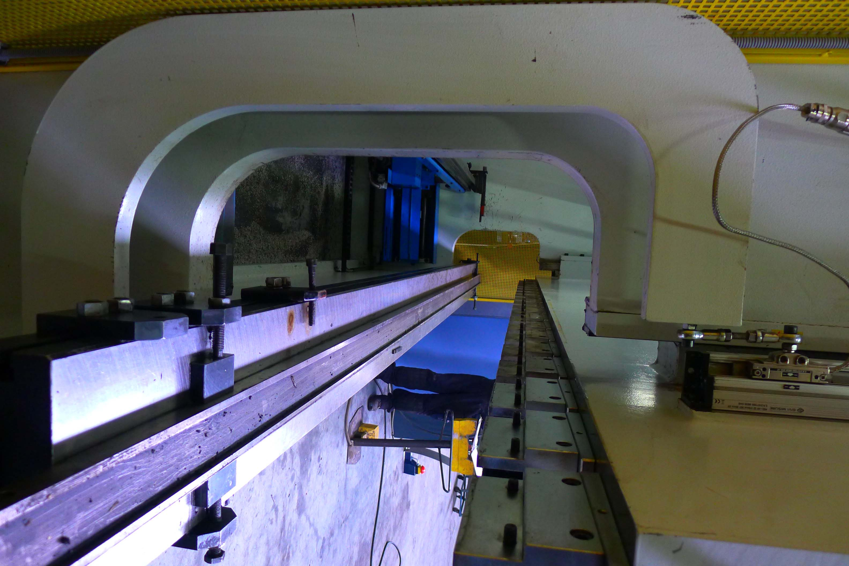
- Length : 5.100
- Width : 2.250
- Height : 2.900
- Weight : 14

- Crowning by hand
- Under power !

Please Note: The above information has been obtained to the best of our ability and belief from, and from the manufacturers where possible. It is given in good faith, but its accuracy can not be guaranteed. Accordingly, it will not form a representation or constitute contractual terms. We advise you to check any vital details!

